Testing ab localhost n: 5000 c: 10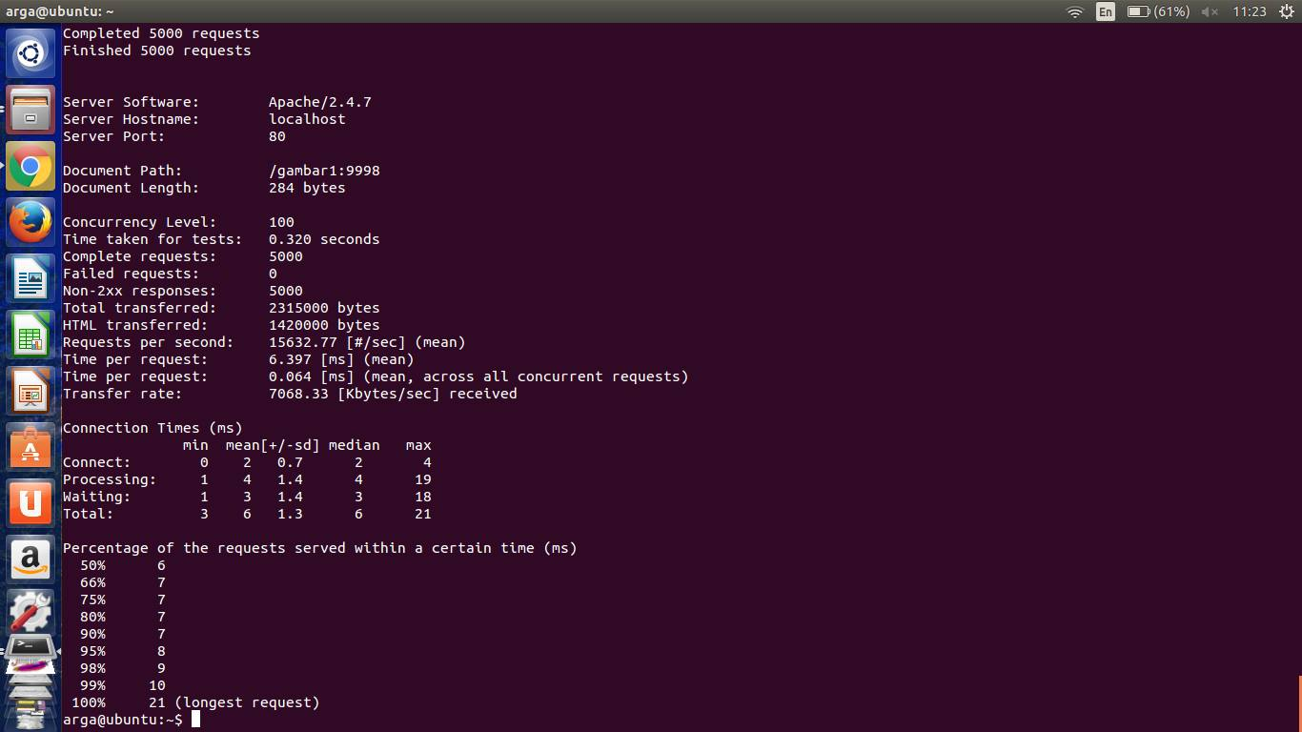

Testing ab localhost n: 5000 c: 200

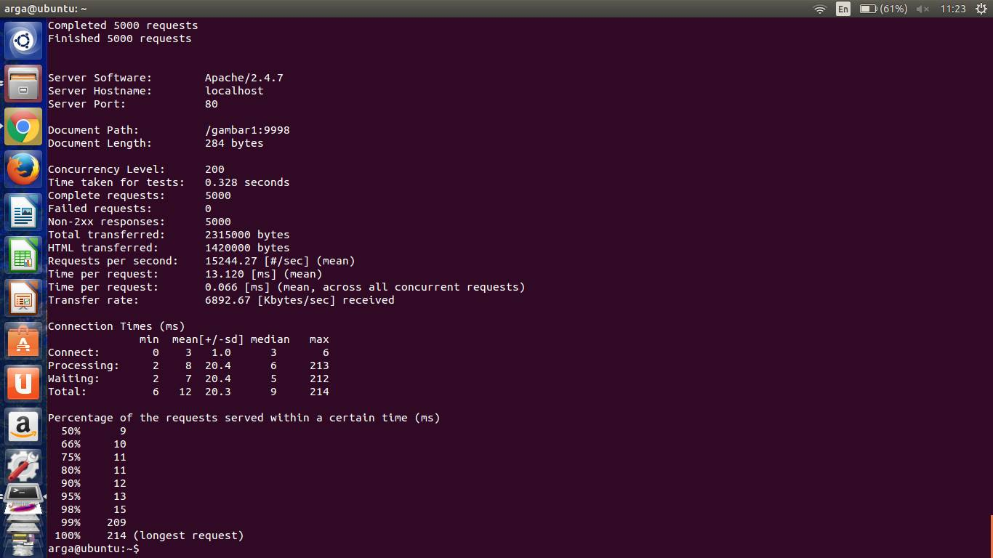

Testing ab localhost n: 5000 c: 500

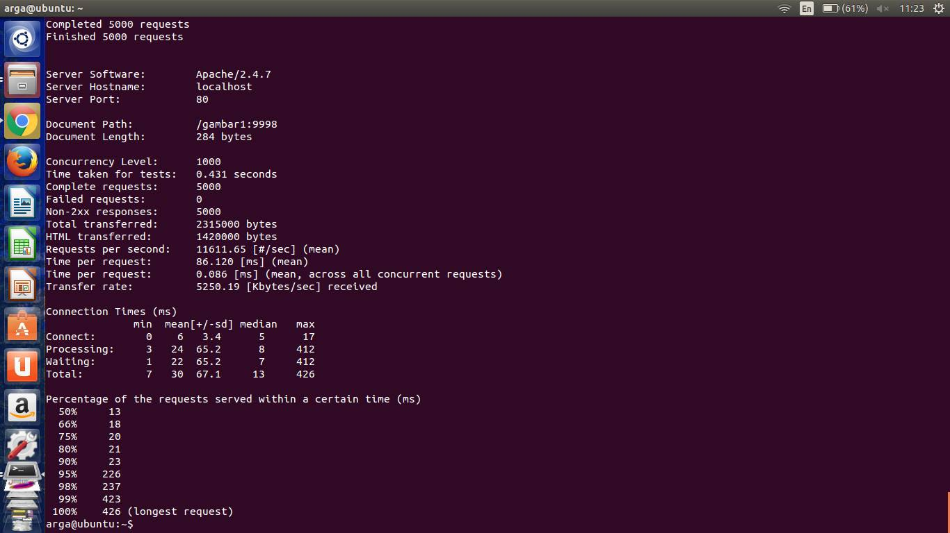

Testing ab localhost n: 5000 c: 1000



Testing ab WIFI n: 5000 c: 100

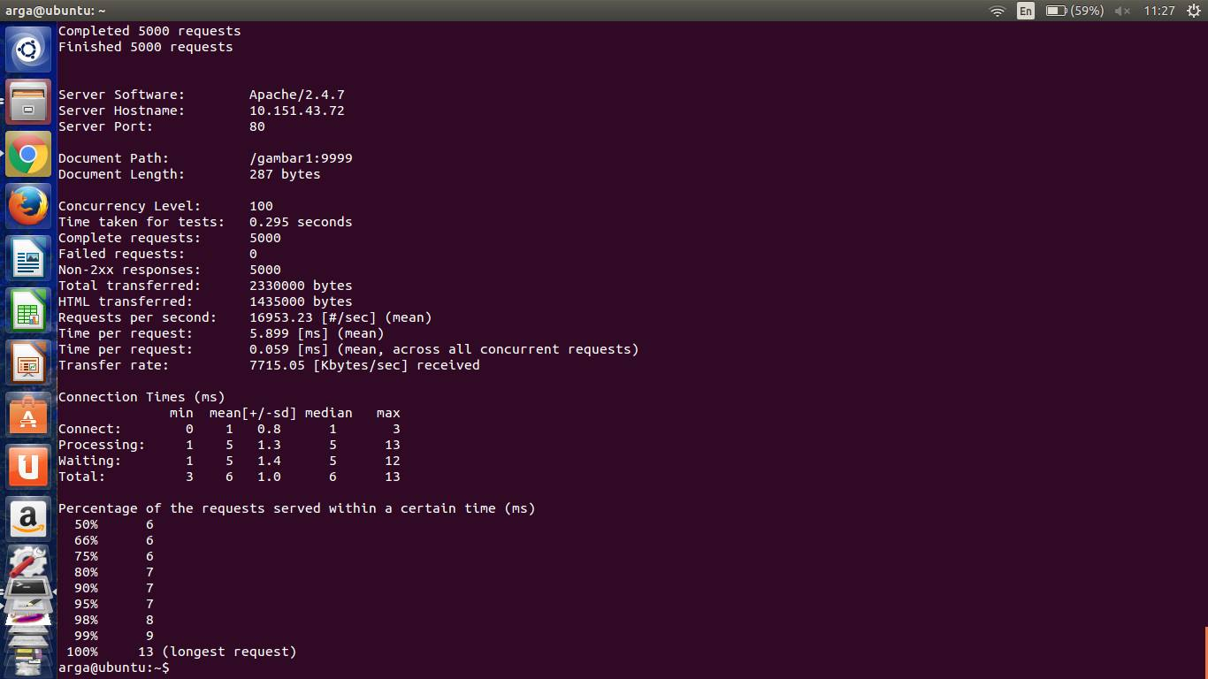

Testing ab WIFI n: 5000 c: 200

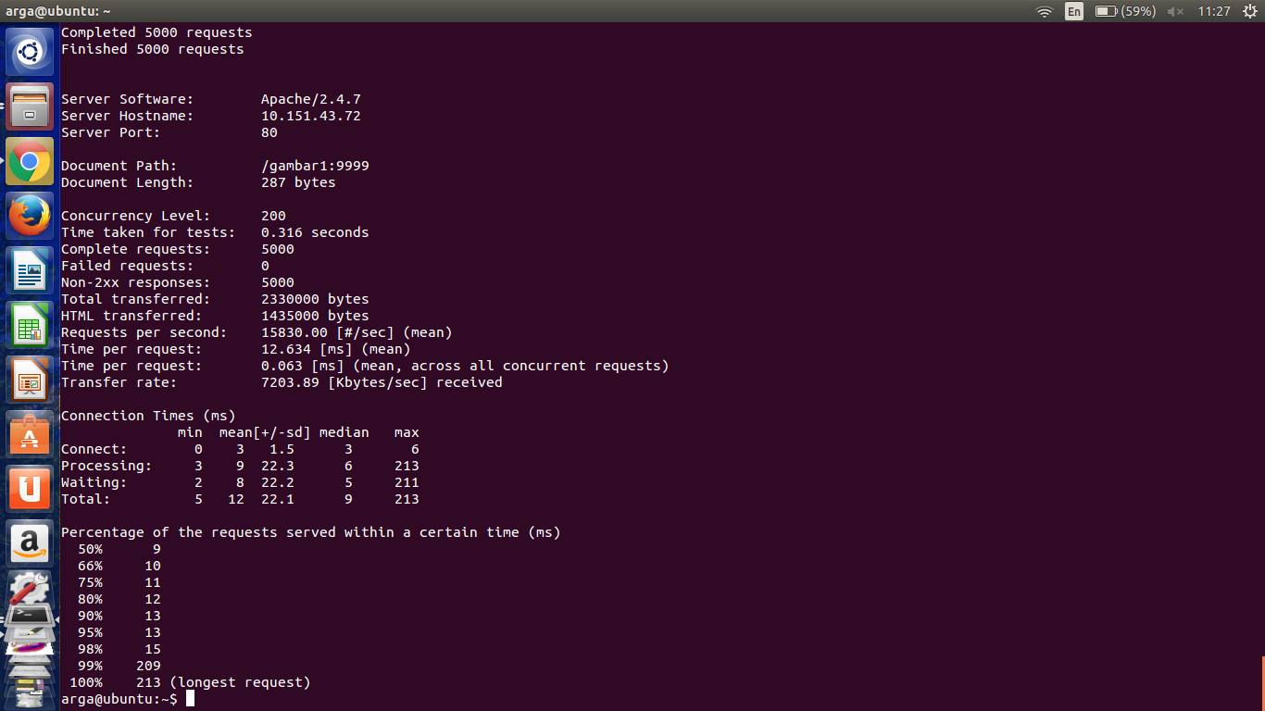

Testing ab WIFI n: 5000 c: 500

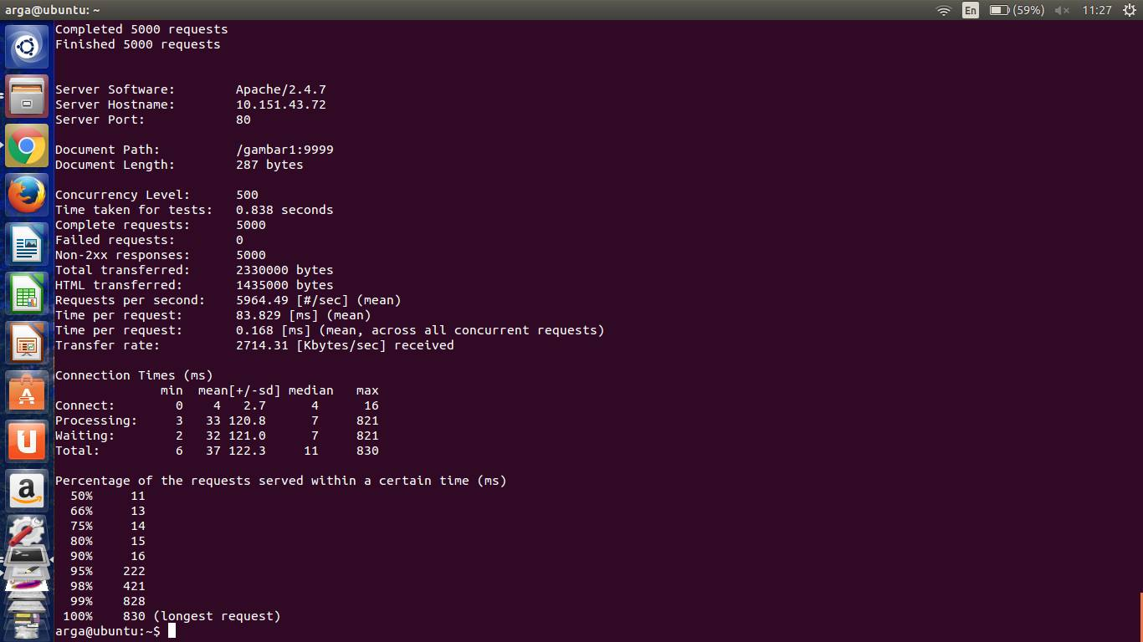

Testing ab WIFI n: 5000 c: 1000

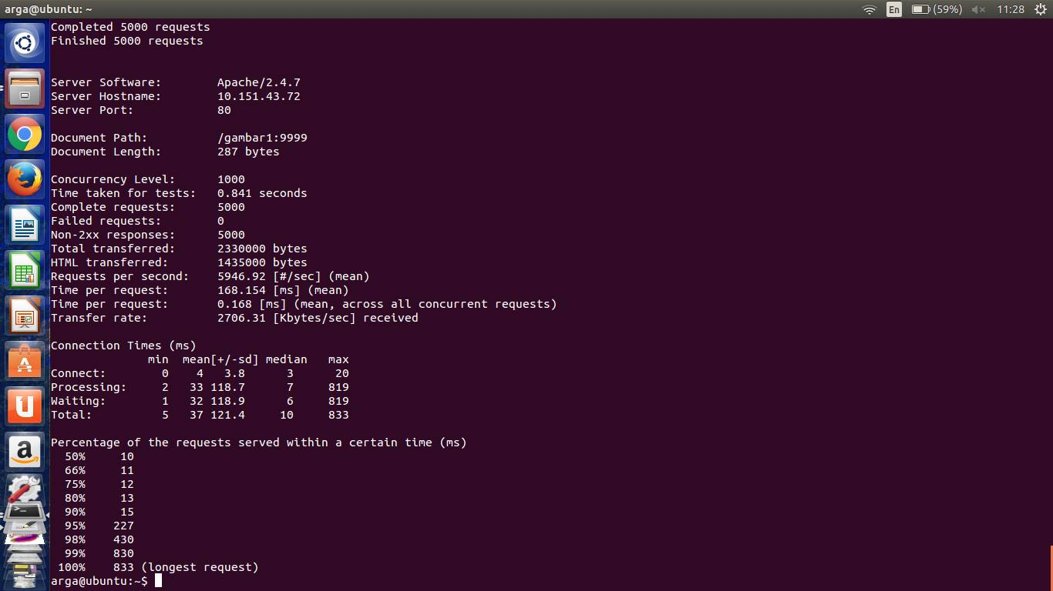

Testing ab LAN n: 5000 c: 100

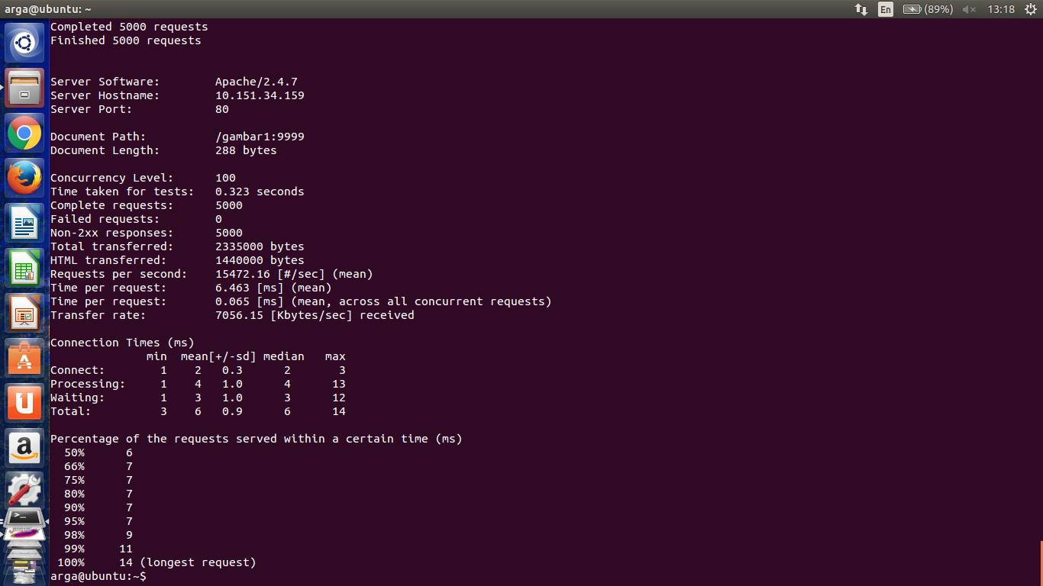

Testing ab LAN n: 5000 c: 200

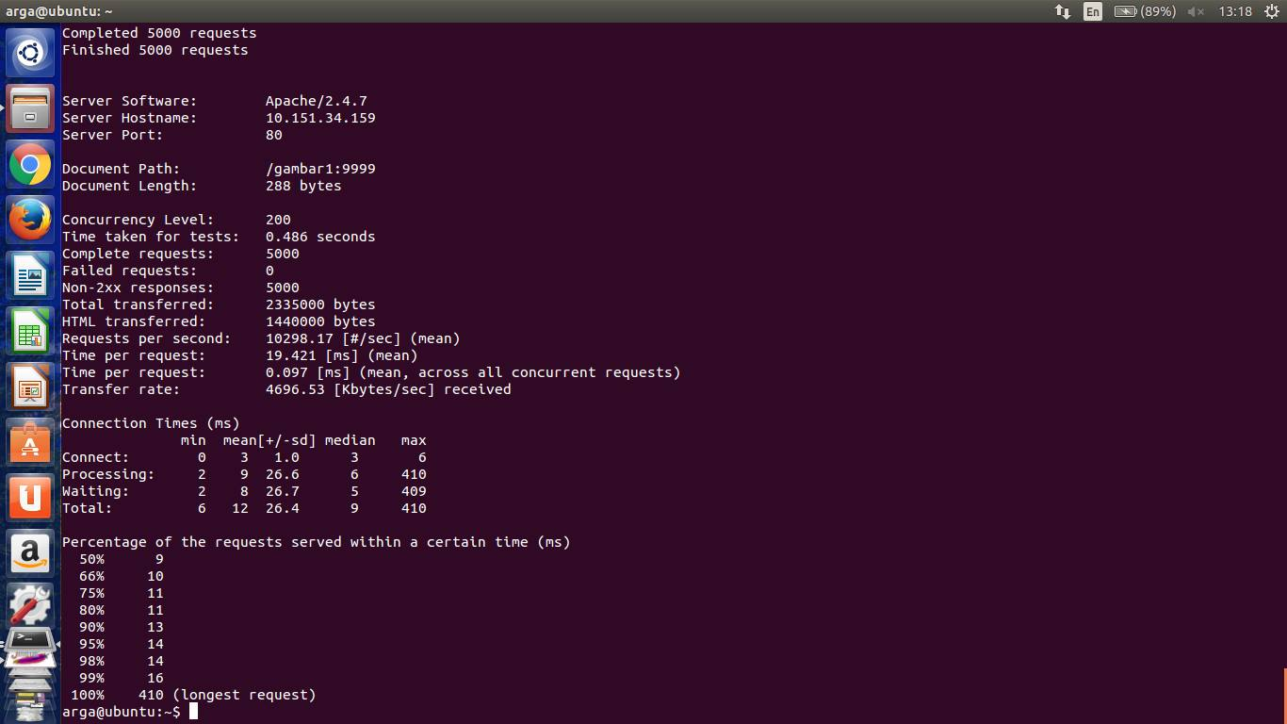

Testing ab LAN n: 5000 c: 500

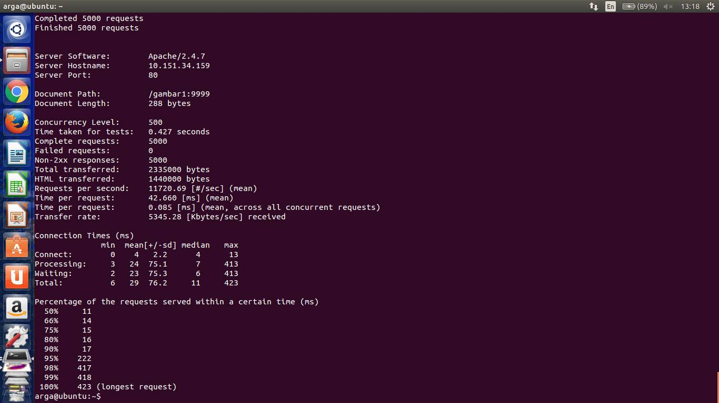

Testing ab LAN n: 5000 c: 1000

